

FULHAM GOOD NEIGHBOURS

VOLUNTEER HANDBOOK
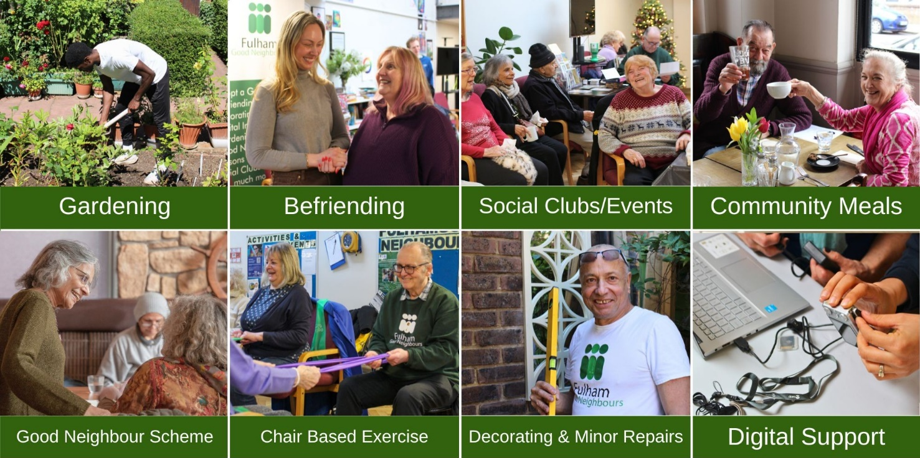


Contents
Welcome 3
Who to Contact 4
Volunteer Roles 5
FAQs 6
Safeguarding 6
Reporting Concerns: 7
Volunteering With Us 8
Other Ways to Help 8
Your Time with our Beneficiaries 9
Health & Safety 10
Lone Working 10
Keeping Safe When Working Alone 11
DOs and DON’Ts 11
Money Management 12

Welcome
Welcome and thank you for volunteering with Fulham Good Neighbours (FGN). Hopefully this handbook will provide a useful reference point; however, please contact us directly with any query or concern.
First, a bit about us. Since 1966, FGN has provided older people and people with disabilities with neighbourly support in their homes and gardens, community and now online. Our history however, can be traced back to the Fulham District Nursing Association from 1919.
Vision Statement: To create an inclusive community where neighbours look out and care for each other.
Mission Statement: We enrich the lives of older people and people with disabilities in Fulham by providing practical help and creating opportunities to: Contribute to society; Connect with others; and Live life to the fullest.
Our Values: Trustworthiness; Being welcoming & inclusive; and Proactivity & flexibility

FGN supports in:
- The Home and Garden via:
  - Gardening and Adopt a Garden: for those who cannot pay, nor do the work themselves
  - Good Neighbour Scheme: shopping, escorting, errands, etc.,
  - Decorating and Minor Home Repairs: for those who cannot pay, nor do the work themselves

- The Community via:
  - Befriending: via telephone, in the home, or the wider community
  - Social clubs:
    - Social Clubs: Art, Choir, Textile, Reading
    - Exercise Clubs: Chair Based Exercise
    - Community meals: Wednesday lunch club, Silver Club Lunch

- Online via:
  - Online Chair Based Exercise: delivered directly into the homes of beneficiaries, particularly those who are housebound
  - Digital Inclusion: supporting those excluded from digital communications, particularly those housebound, including one-to-one volunteer support, device loan & internet connectivity, a digital drop-in class, and Techy Tea parties.


Who to Contact
Fulham Good Neighbours, Rosaline Hall, 70 Rosaline Road, SW6 7QT. 020 7385 8850; and info@fulhamgoodneighbours.org.
Office hours are weekdays 9am to 5pm.

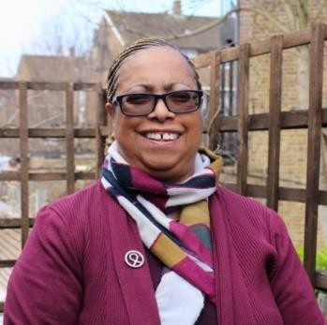



Flora Taylor

Chief Executive
Tel: 020 7385 8850
Email: florataylor@fulhamgoo dneighbours.org
Ruth George
Social Club Coordinator
Tel: 07701 238177
Email: ruthgeorge@fulhamgood neighbours.org
Jac Davies
Finance Coordinator
Email: jacdavies@fulhamgoodne ighbours.org
Barney Valentine
Gardening Projects Coordinator Tel: 07730 727952
Email: barneyvalentine@fulhamg oodneighbours.org
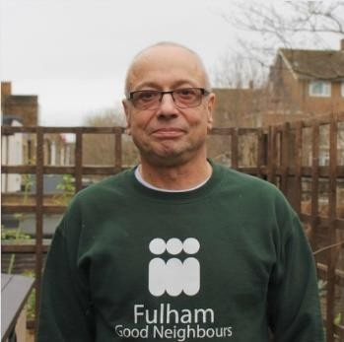

Alana Mann

Volunteer Coordinator
Tel: 07475 051543
Email: alanamann@fulhamgoodneighbours.org
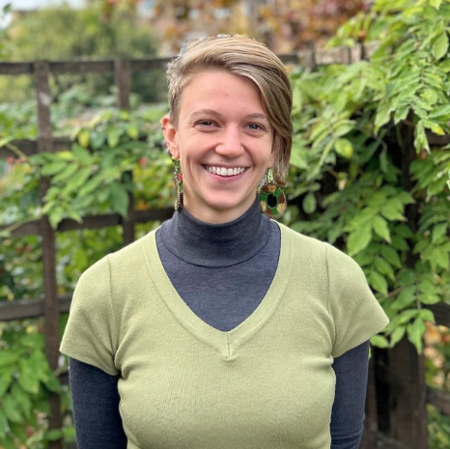
Rubab Suhail
Volunteer Coordinator DI
Tel: 020 7385 8850
Email: rubabbutt@fulhamgood neighbours.org
Steve Fay
Decorating and Home Repair Coordinator Tel: 07564 881702
Email: stephenfay@fulhamgood neighbours.org

For outside support, please contact LBHF Adult Social Care on 0800 1456095, or outside office hours call 020 8748 8588, or email safeguardingadults@lbhf.gov.uk.
For urgent medical (but, non-life threatening) help, please contact 111 - NHS emergency medical helpline. In an emergency or life-threatening situation, please contact 999.

Volunteer Roles
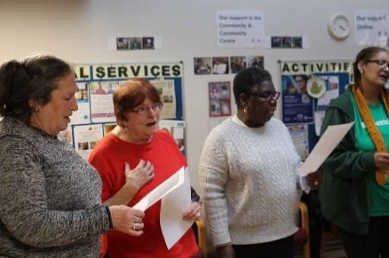
Befriending volunteer: Volunteers are matched to beneficiaries and connect with them on a weekly or monthly basis. This can be in-person or over the phone.
Digital Inclusion volunteer: Volunteers are matched to beneficiaries, visiting the home so to support one-to-one with e.g. online calls, online shopping, tablet/smartphone use. There is no prescribed schedule, providing flexibility to work to the beneficiary’s requirements and learning speed. Volunteers may also assist with group activities.
Gardening volunteer: Volunteers will accompany Barney, our gardener, to various gardening jobs and Adopt a Garden. Beneficiaries are unable to do the gardening themselves and have a garden requiring only basic maintenance and care.

Good Neighbours Scheme volunteer: Volunteers complete practical tasks for beneficiaries. Examples include: Domestic support; escorting to appointments; medication delivery, shopping, wheelchair pushing, etc.,

Home Repairs volunteer: Volunteers assist our Decorator and Home Repair Coordinator during weekdays. Beneficiaries are unable to do tasks for themselves; and cannot afford to pay privately. No formal experience is necessary.

Office volunteer: Volunteers perform administrative tasks or provide expertise with IT, design, excel etc. Examples include: responding to enquiries, photocopying, managing files etc. Ideally this requires a weekly commitment.

Parsons Green Fair volunteer: Occurs annually in July. Volunteers ensure a safe and welcoming experience for 8,000+ visitors, including: marshalling; ensuring safe/clean areas; or lending a hand on the Fulham Good Neighbours Stand.

Social Club volunteer: Volunteers may support our regular clubs. They prepare the room and refreshments, encourage discussion, and support participation. Clubs include: Art, Choir, Textiles, Reading, Chair Based Exercise, and Silver Clubs. We also recruit volunteers to assist with preparing and cleaning up community meals.

Trustee: Trustees govern the charity, support sub-committees and the AGM and meet every other month. In order to better represent the community with which we work, we are especially welcoming trustees from a minority ethnic background.

We ask that every volunteer commits to one task a month.

FAQs
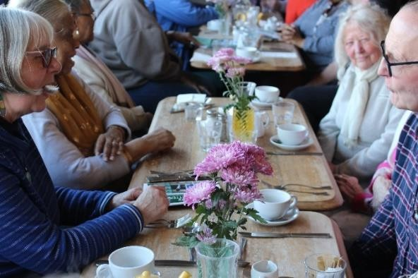
Can I bring a friend or family member? No; all volunteers must be registered, requiring two approved references and a DBS check. Please refer any friends or family to register with FGN.
Can I give my personal details to a beneficiary? Please provide the FGN number/email only, FGN can pass any message on. When you call a beneficiary, hide your caller ID using 141 before dialing the number.
If a beneficiary says something that I
disagree with or which makes me feel uncomfortable, what should I do? Feel free to politely state your disagreement or move the conversation on. If it is inappropriate/offensive, please inform FGN.
What if a beneficiary shares information which worries me? If additional support is required (e.g. with finances, housing, bereavement etc.) please inform FGN where we can signpost to relevant services. Please also see the Safeguarding section of this handbook; and ensure to attend FGN’s safeguarding training.
Shall I accept gifts? You may only accept gifts of small value (up to £10) when not accepting them would cause offence. Please declare this to FGN. Politely decline any higher value gifts.
What shall I do if there is no reply when have I arranged to meet the beneficiary? The appointment may have been forgotten, but there is also the possibility of harm
e.g. a fall. Please contact FGN. If staff are not available, please contact LBHF Adult Social Care and request a welfare check. They are open 24 hours.

Safeguarding
What is Adult Safeguarding? ‘protecting an adult’s right to live in safety, free from abuse and neglect.’ FGN will not tolerate abuse or neglect. We are committed to safeguarding all adults, particularly those with care and support needs. Please familiarise yourself with FGN’s Adult Safeguarding Policy and Procedure.
Dealing with disclosures
- Get brief details about what has happened and what the adult would like done, but do not probe or conduct a mini investigation. Do not, under any circumstance, approach the alleged abuser.
- Seek consent from the adult to take action and to report the concern.
- Consider whether the adult lacks capacity to make decisions about their own/other people’s safety and wellbeing. If you act against their wishes or without their consent, you must record your decision and the reasons for this.

Reporting Concerns:
If you are concerned for someone’s safety i.e.

you see or suspect  abuse/neglect | an allegation of  abuse/neglect is made | someone reports  abuse/neglect

Immediately discuss your concerns with your coordinator. If the coordinator is not available or the concern relates to the coordinator, contact the safeguarding lead, CEO Flora Taylor, on florataylor@fulhamgoodneighbours.org or 020 7385 8850. If they are not contactable, or is the individual suspected of abuse/neglect:
volunteers should call LBHF Adult Social Care on 08001456095 (8:45am to 5pm, Monday to Friday). Outside office hours contact 020887488588 or email safeguardingadults@lbhf.gov.uk. contact LBHF Access & Advice Team (020 8753 4198 - option 3).
Focus discussion on:
- Nature of concerns
- Risks to individual(s)
- Action/next steps
Report concerns as soon as possible: This should normally be on the same working day. Do not delay in passing the information on and seeking further advice on next steps.
Make a record: Ensure detailed records are made of all events (with dates and times) and include what the individual(s) has said (where applicable).

NB: In an emergency and where there is immediate risk ACT!
It is essential to avoid delay as inaction may place the individual at further risk. Inform your coordinator/safeguarding lead as soon as possible. If contact cannot be made appropriate action should be undertaken e.g. contact emergency services on 999.
Bottom Line: If you have any concern whatsoever, no matter how small it may seem, report it to a member of FGN. It’s always better to be safe than sorry.

Volunteering With Us
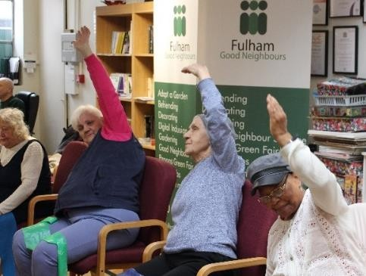
Equality and Diversity: We are committed to recruiting volunteers from a diverse range of backgrounds, reflecting the community we serve. No one should suffer discrimination. Everyone should follow our equal opportunity policy.

References and DBS: Volunteers should provide two referees, prior to volunteering. We will also complete DBS checks, as required.

Induction, ongoing training and recognizing your support: We offer ongoing training opportunities and volunteer social events. Volunteers are also invited to our annual AGM. Please look out for emails from volunteer coordinators for more information.

Database (CharityLog): All tasks are now received by the office and recorded in CharityLog, our secure database holding all volunteer and beneficiary records. You will be emailed or called by staff regarding a specific task; upon acceptance, staff will provide full details via email or phone so you can proceed directly.
Expenses: We will pay reasonable expenses, if receipted, for authorised tasks e.g. bus fares, parking, mileage (45p per mile). We can also reimburse calls, and meals up to £5 for 3.5+ hours volunteering. We reimburse monthly in cash at Rosaline Hall or via BACS. For expense claims of 5+ receipts please use the Volunteer Expense Claim, which can be found on our website.

Complaints: Please bring any complaint to the relevant staff member. If you are not satisfied, or if you prefer, please refer it to the Chief Executive. Following this, you can appeal to the Trustees. Volunteers are expected to comply with our general principles and practices but have the right to discuss any request.

Other Ways to Help
Spread the word: Please encourage others to access our services or volunteer. Please get in touch if you can support leaflet or newsletter distribution.
Amazon Smile: Sign up to Amazon Smile, select Fulham Good Neighbours, and 0.5% of your purchase cost, at no cost to you, will be donated to us.
Give as You Live: Sign up to Give as You Live and we will receive donations, at no cost to you, with each purchase.
Sponsored challenges: We welcome runners and cyclists, eager to raise funds; and any other creative fundraising ideas.

Your Time with our Beneficiaries

Assisting a wheelchair user:
We provide written manuals at our volunteer induction. We also provide training, if relevant at Rosaline Hall. Please direct any queries or concerns to our staff.

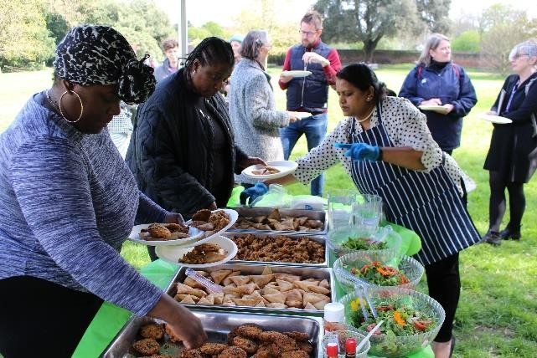
Communicating effectively:
On occasion volunteers may face communication challenges with beneficiaries. Some common barriers include: sensory impairment, such as speech/hearing difficulties; distress; English being an additional language/unfamiliar accents; physical/mental illness affecting
concentration/memory; level of literacy;
or inappropriate vocabulary/jargon.
Discuss any concerns with your coordinator.

Communication tips:
Don’t assume anything - check that you are understood; reflect back what has been said; Ask how best to communicate; consider alternative methods. Perhaps there is an underlying illness or sensory impairment; Ask open-ended questions; avoid closed (yes/no) questions; Allow for silences or thinking time.

Confidentiality for Beneficiaries: Confidentiality must be maintained. Please ensure all communication (electronic or hard copy) is securely maintained and used only as required. Delete any information that is not necessary to keep.

Confidentiality for You: Your data is held on a secure database; you can access this on request. We will never sell, lend or share personal data externally. A court order would be the only exception. Please do not share your contact details; instead ask beneficiaries to contact you via FGN. We can pass any message on. Use prefix ‘141’ when telephoning a beneficiary so that your telephone number is not revealed to them. Please avoid any situations where your personal, financial or other interests might hinder your capability as a volunteer. Always declare any potential conflicts of interest to staff.

Insurance: We have a comprehensive insurance policy. Should you suffer an accident/injury/cause damage to someone/property, inform FGN asap. Inform us also of any additional tasks, which you undertake, since our insurers only cover tasks noted by us. Do not provide any financial, medical or other advice.

Health & Safety
Please take all precautions to protect yourself and any beneficiary. Volunteering is varied, and it is difficult to detail all safety precautions but we advise against: heavy lifting; electrical/specialist repairs; using electric equipment; standing on anything apart from a step-ladder; external work above ground level; any tasks that you are not comfortable with. If required, you will need to complete Manual Handling, Wheelchair, and Ladder Safety Training when relevant to your volunteer role – ask your coordinator for the details.
Risk: There are limitations on all policies; volunteers should not take unnecessary risks. Examples include: sitting on a ledge to window clean, climbing ladders, standing on chairs. Volunteers who drive beneficiaries will be required to provide their license and insurance policy. Please inform your insurer and FGN of any penalty points/motoring convictions. Please inform your coordinator if you injure yourself during a visit.

Lone Working

Only visit a beneficiary when requested by our staff and when scheduled. An ongoing agreement, such as Adopt a Garden or Befriending, is an exception to this. FGN will not knowingly put you at risk. However, sometimes conditions will be unknown to us. You have a responsibility to:
Assess risk: Take reasonable care of your own/other people’s safety; and be aware
of your surroundings and possible threats to your personal safety. When entering a
beneficiary’s home, note the exit in case you need to make a swift exit. Do not allow
them to lock the door with you inside their property.

Manage risk: Inform someone where you are going and what time you are expected back; keep to your scheduled times; let FGN know of any delays; park in well-lit areas, leave valuables out of sight; fully charge your mobile phone; and put emergency phone numbers and FGN on ‘speed dial’. Leave any environment if there is a threat to your safety; follow FGN’s policies/procedures; use equipment only in accordance with training; and undertake and follow any training provided.
Report risk: If you are concerned for your safety, leave ASAP and report it to FGN. Tell us when safety measures are not adequate/you encounter a ‘near miss’ or identify previously unidentified risks, report aggression or violence to us; and report any actual accidents or incidents that occur. If you have concerns about your working environment or the tasks you are asked to perform, please contact FGN.

What happens if you are ill, have an accident, or is there an emergency?
Please inform staff asap. A First Aid kit and staff trained in First Aid are available at Rosaline Hall. In an emergency, please call 999 and request the relevant rescue service. Otherwise call LBHF Adult Social Care on 080 0145 6095 (8:45am to 5pm, Monday to Friday). Outside office hours contact 020 88748 8588 or email safeguardingadults@lbhf.gov.uk.

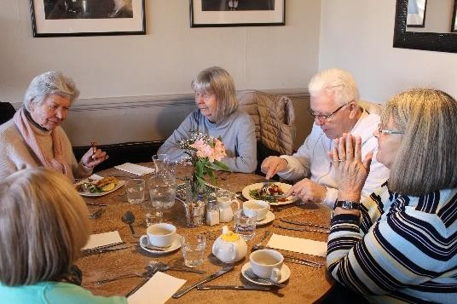
DOs and DON’Ts
DO:
- Call the beneficiary by their title (Mr/Mrs/Miss) and surname unless asked not to.
- Think before you share too much; ensure you are comfortable with any personal disclosure.
- Refer new tasks to FGN, unless it is something small (e.g. buying a pint of milk).
- Leave immediately if you feel unsafe
and report this to FGN Staff.
DON’T:
- Visit beneficiaries when under the influence of alcohol/non-prescribed drugs. Likewise, you are not expected to remain in the home of anyone who is.
- Give personal care or administer any medication.
- Make promises you cannot keep. If you are unsure of whether to take on a task, we can advise, or we can ask another skilled volunteer.
- Give advice. FGN may help find specialists to support with benefits, medical advice, housing, family difficulties etc.
- Smoke.
- Hold a set of keys to the beneficiary’s property.

Money Management
Purchasing items for a beneficiary: Beneficiaries must complete and sign a ‘Beneficiaries Money Handling Policy’ which can be found on our website. Please return the form to Rosaline Hall in person or email.
Other circumstances: We encourage family members/paid carers to handle a beneficiary’s financial transactions. The Money Carer Foundation can provide additional support. Nevertheless:
Cheques: Volunteers should not write a cheque on behalf of a beneficiary. Instead, you can accompany them to their bank or contact their bank to arrange a home visit.
Bank, debit & credit cards: including online shopping: Volunteers must not handle a beneficiary’s cards/PIN/long number. Please contact FGN for further guidance.
Online banking: Volunteers must not be involved in a beneficiary’s online
banking.
Reimbursing volunteers: Volunteers might obtain or shop for small value items, which a beneficiary reimburses to Fulham Good Neighbours if the item is paid for by the volunteer. FGN then reimburses the volunteer. Receipts must be provided. The volunteer is under no obligation to carry out shopping tasks and please note: the total should not exceed £40.
Online purchases: Volunteers must not record the password of a beneficiary.
Donations: Beneficiaries are encouraged to donate via our website, cash or cheque. All donations can be accepted via volunteers. These should be taken to Rosaline Hall asap. Beneficiaries may also donate by cheque making cheques payable to 'Fulham Good Neighbour Service'. Or via our website at a cost to FGN. Each donation is acknowledged with a receipt, specifying the amount.

VOLUNTEER AGREEMENT

I [print name]

confirm that I have read the Volunteer Handbook, and agree to abide by the Fulham Good Neighbours guidelines, processes and procedures including:

Safeguarding

Insurance

Health & Safety

Lone Working

Money Management

Signed Date

