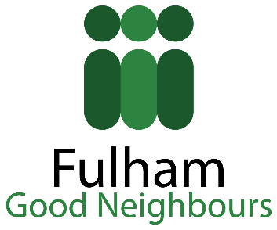 I AM a Fulham GOOD NEIGHBOUR

Does your business come across older people who appear lonely/isolated or maybe in need of support? If so, we would like to invite you to become a Fulham Good Neighbour. The aim of the campaign is to ensure that all local older people in need are supported appropriately. Have you come across an older person who could benefit from FREE:
- decorating;
- befriending;
- gardening;
- practical help (e.g. small DIY, being accompanied to appointments, pushed in a wheelchair, emergency shopping);
- social clubs (e.g. Fulham Lunch Club, Chair Based Exercise Group, Art Group, Carers Group, Reading Group)
- signposting to the most appropriate service?

If so, we would like to invite you to any or all of the following:
- display I AM A FULHAM GOOD NEIGHBOUR sticker at your front door;
- pass on our contact details to anyone who could benefit from support (e.g. by passing on our leaflet);
- promote your discounted goods/services via our newsletter read every month by over 600 local people;
- have our collection box on your premises;

If you could become a Fulham Good Neighbour, please contact:
Chris Mikata
Fulham Good Neighbours
Rosaline Hall
70 Rosaline Road
London, SW6 7QT
Tel. 020 7385 8850
Email: chrismikata@fulhamgoodneighbours.org
Web: www.fulhamgoodneighbours.org

