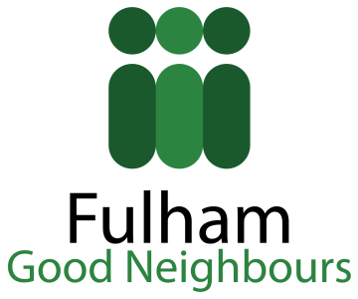 | Fulham Good Neighbour Service  Rosaline Hall, 70 Rosaline Road  London SW6 7QT  Tel. 020 7385 8850  FulGdNeighbours  Email info@fulhamgoodneighbours.org  Web www.fulhamgoodneighbours.org  President: Mayor of Hammersmith and Fulham

Offering practical support and friendship to older people in Fulham since 1966.
ADOPT A GARDEN VOLUNTEERS INFO-SHEET

Dear Volunteer,

Thank you for supporting your local neighbour with regular gardening. The idea behind the service is that it will create better links between local neighbours and ultimately create a community where people look out for and support each other.

On a practical level you will be matched with an older/disabled person who has a garden but who is:
a) Not physically able to do gardening themselves;
b) Unable to get help from anyone else to do it for them;
c) not able to pay for this service privately.
We hope that you will visit ‘your’ matched beneficiary on a regular basis; depending on the garden they have this may be every 4 to 12 weeks. Please report every visit to Cathy with a date so that she can keep track of everyone.

We do hope that the match will work for both parties but please do contact the office if you have any questions or concerns. In particular please:
a) do follow our Gardening Risk Assessment
e) do follow our Lone Working Policy

Thank you and we hope you will find this an enjoyable and rewarding experience!!!

Krzysztof Mikata-Pralat
Director
Fulham Good Neighbours
Rosaline Hall
70 Rosaline Road
London, SW6 7QT
Tel. 020 7385 8850
Fax. 020 7385 0924
Email: chrismikata@fulhamgoodneighbours.org
Web: www.fulhamgoodneighbours.org

